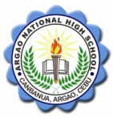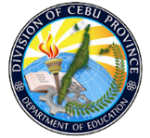Republic of the Philippines

Department of Education

Region VII, Central Visayas

Division of Cebu Province

**ARGAO NATIONAL HIGH SCHOOL**

Canbanua, Argao, Cebu

**WORK IMMERSION LEARNER MONITORING SHEET S.Y. 2022-2023**

|  |  |  |  |
| --- | --- | --- | --- |
| **Date** | **Name** | **CIGS ( Concern, Issues, Gaps )** | **Actions Taken/Actions to be Taken** |
| March 30, 2023 | Few identified Immersion learners from CTU Canteen and Jessie’s Torta | Recurring absences of Immersion learners | * Foster a positive and inclusive environment that encourages collaboration, empathy, and mutual respect among students. * Conduct regular check-ins with students to identify any peer-related issues or concerns and address them promptly * Re-oriented the immersion learners regarding duties and responsibilities and ensure that absences will be covered |
|  |  |  |  |

Prepared by: Noted by:

**MIGUELLA DELOS SANTOS** **ELMA M. LARUMBE**

Work Immersion Focal Person SSP IV